Name – Davender Singh

Student ID – **********

Course – CCP555NSA

Professor – David Humphrey

**GitHub repo links:**

**Fragments:** <https://github.com/davender-singh1/fragments>

**Fragments-ui:** <https://github.com/davender-singh1/fragments-ui>

Screenshots:

Page load when not logged in:

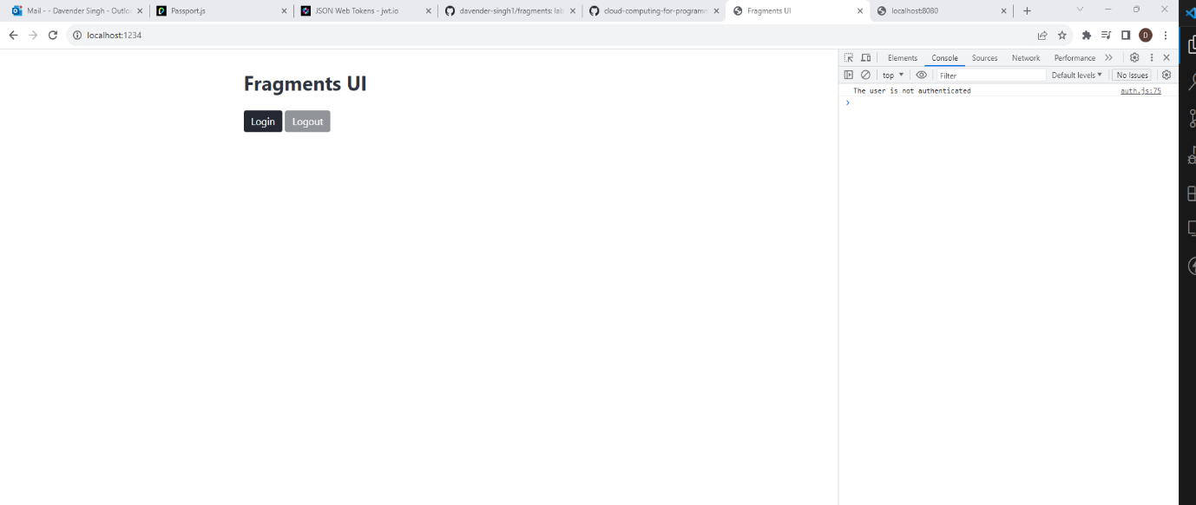

Clicking the **Login** button and being redirected to the **Hosted UI:**

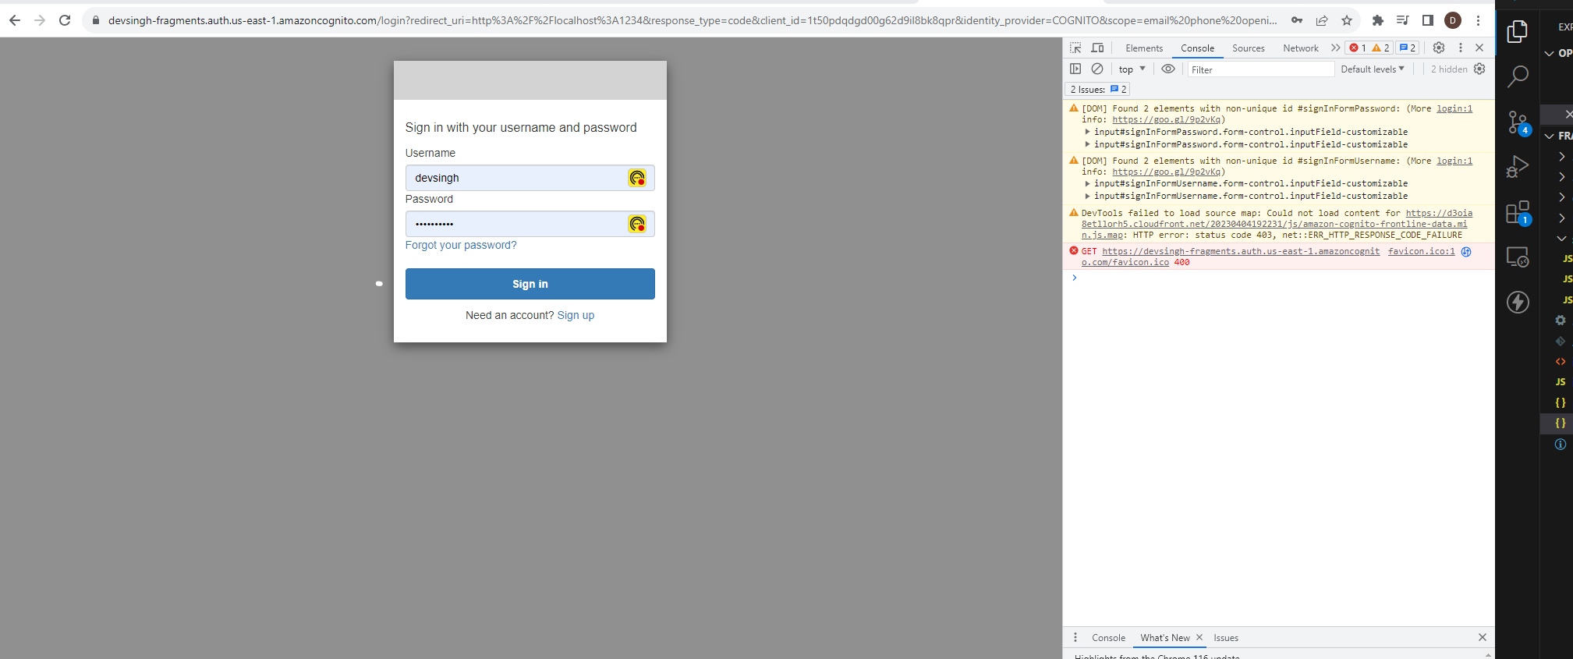

Page load when logged in:

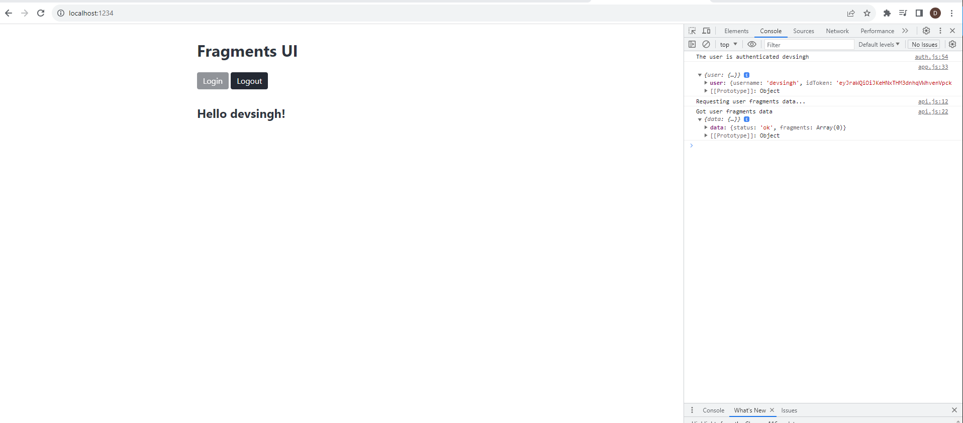

**AWS Console Cognito** page in the **Users and groups** section:

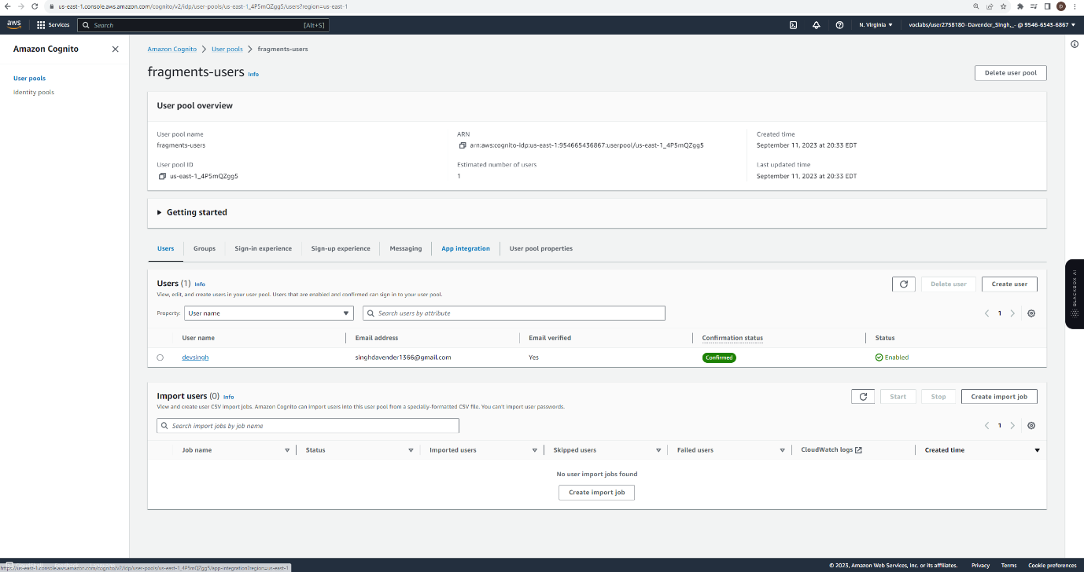

Fragments server logs:

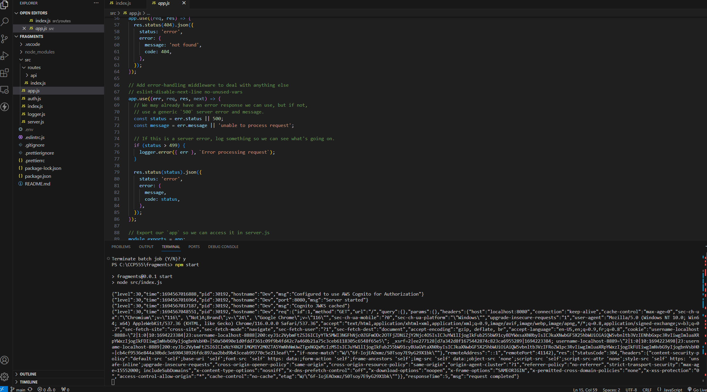

**Decoded** payload:

